New routine

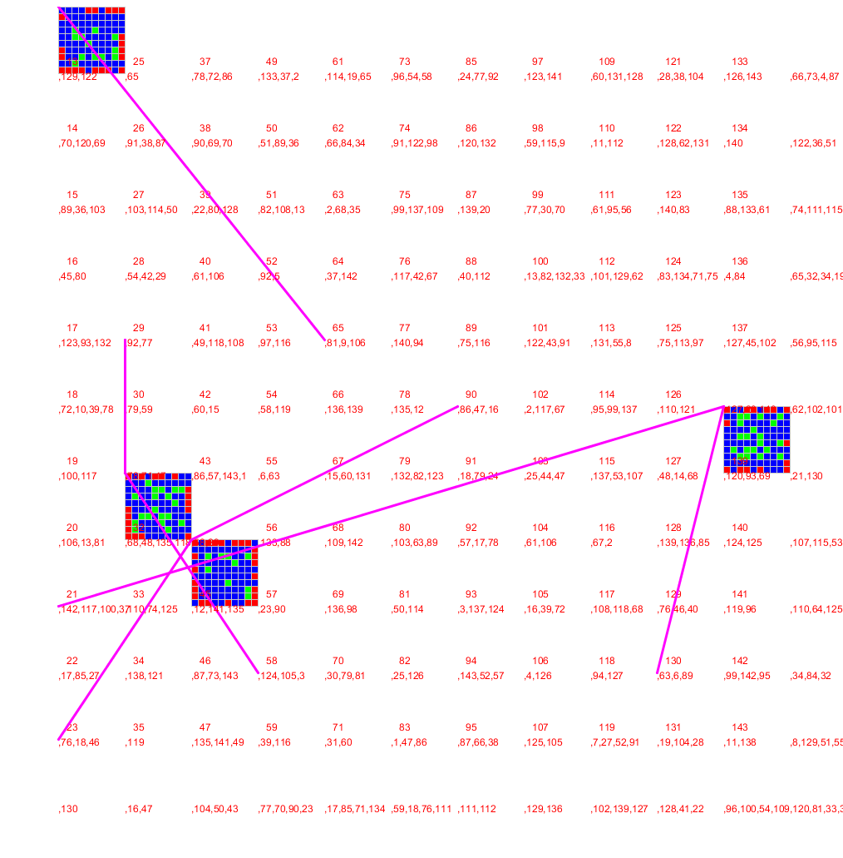

Old Routine

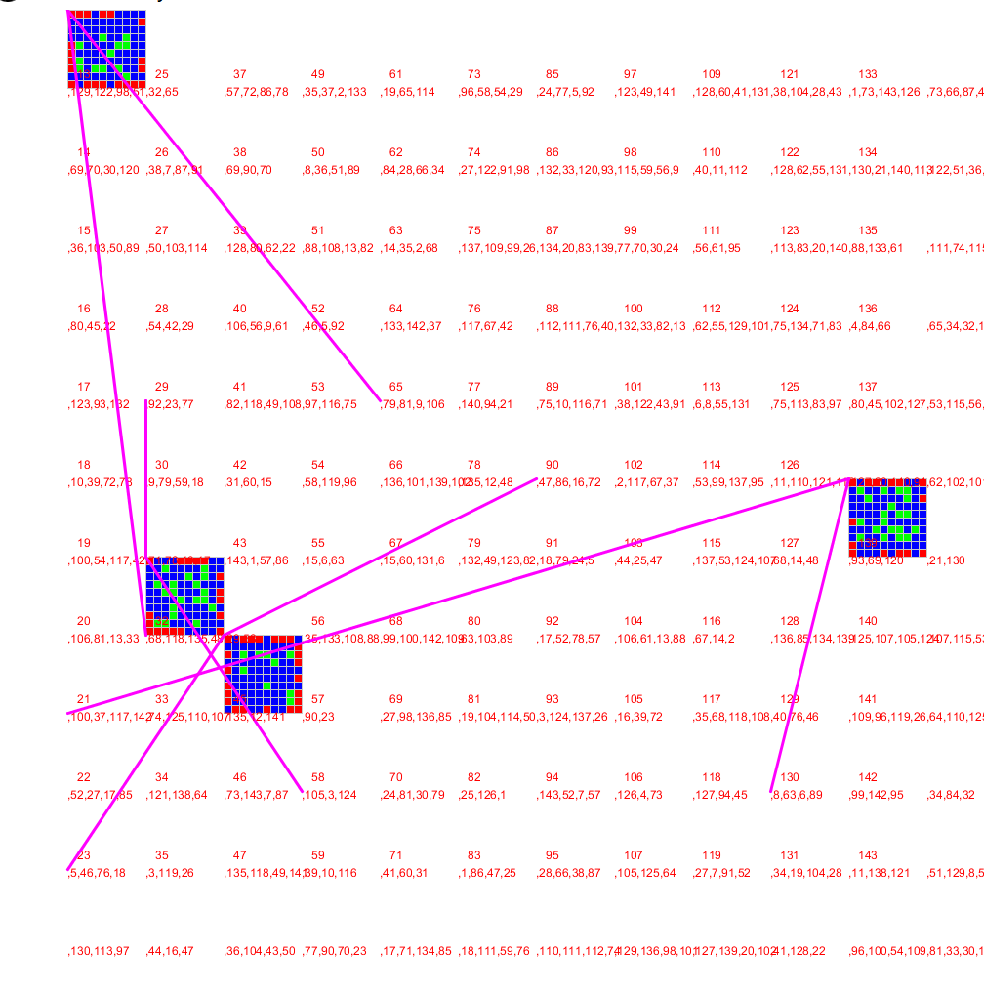

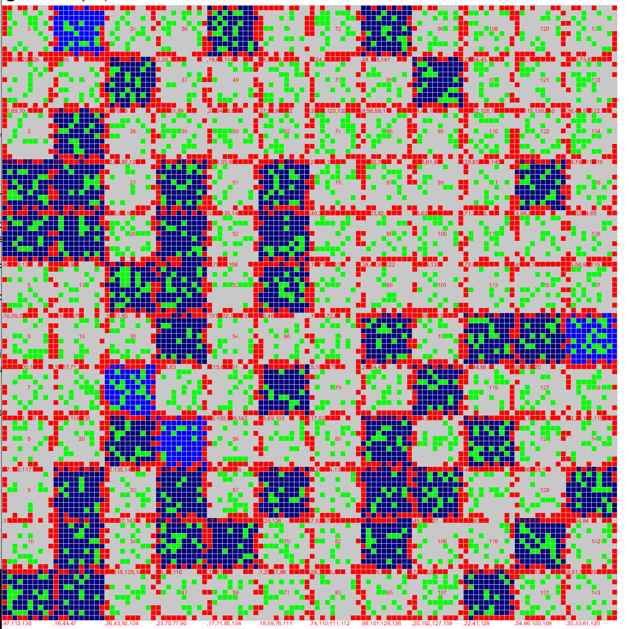

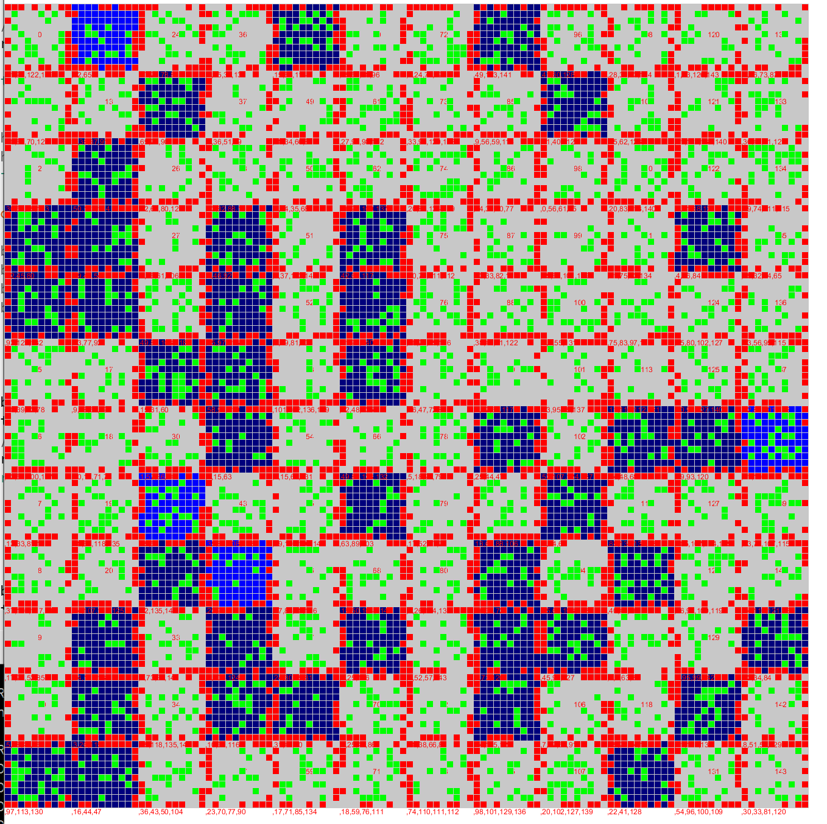

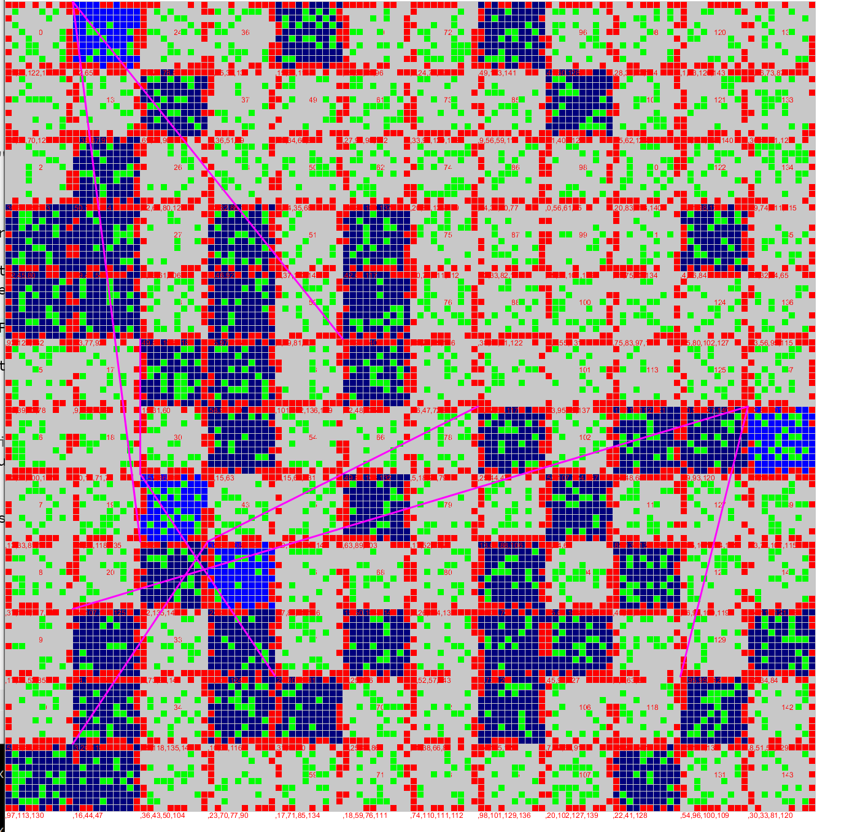

Tile number 12 is an acceptable orientation to move to 0,0 and make this the starting point of piecing this together.

Algorithm?

1. Start with a known good piece, add to new board
2. Build a sublist of neighbour pieces from unorganised pool (excluding any that are already sorted)
3. For each piece in sublist;
   1. Rotate/flip until it aligns with “know good piece”
   2. Add to new board
4. (TBD if this is recursive or iterative) repeat algorithm for each new board piece until all elements are added to board